# Guide-Setup Google Analytics

## Web Application Development COP3834

## Professor Navarro

1. Navigate URL to <https://analytics.google.com/> and select Start Measuring
2. Setup Account Name, click Next 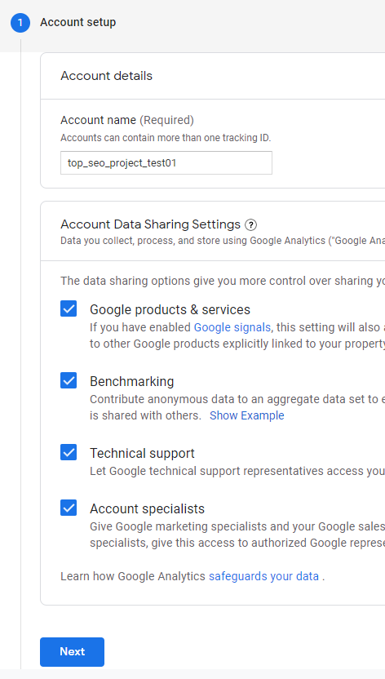
3. Setup a property name, such as the name of your domain 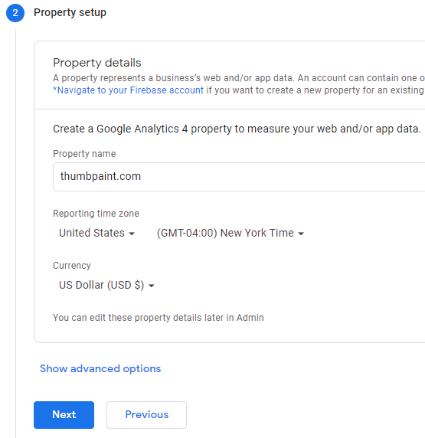
4. Configure Business Information, click Create 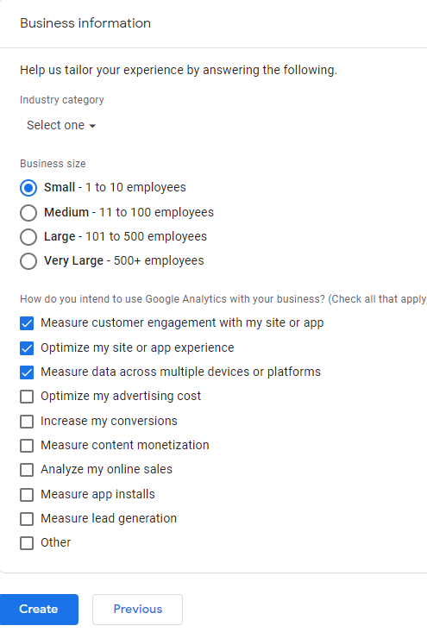
5. Select Setup Assistant 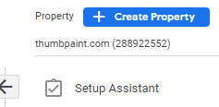
6. Select Arrow next to Tag Installation 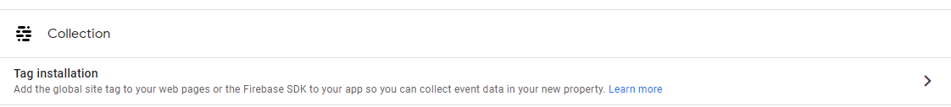
7. Choose a platform – Web 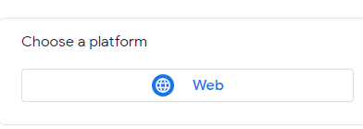
8. Complete settings for stream with website URL (use HTTP), Click Create Stream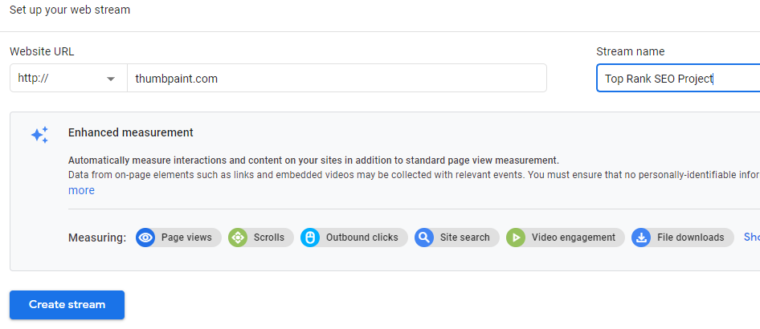
9. Select Add new on-page tag

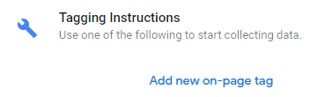

1. Use Google site tag. Copy the script to the head section of your html. 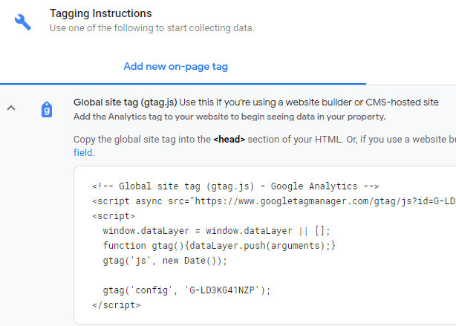
2. Add script to your index.html using vim or another editor.:wq 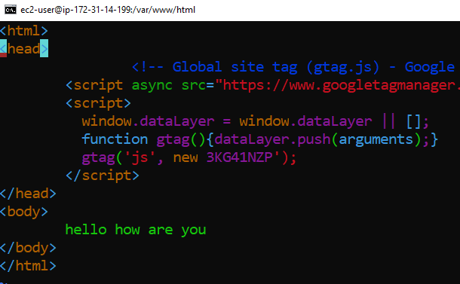
3. Close Analytics configuration and select Reports on left tool bar 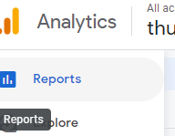
4. Visit your landing page on the ec2 instance
5. Select Realtime on left side , real time stats should indicate a single user.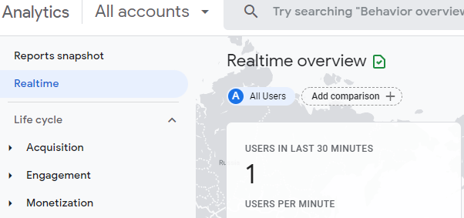
6. View Life Cycle section for historical data